Assignment 1
Module: Fundamentals of Data Science
Student Name: Sizone Giri

Program 1:

Description of the Program:
Translates the following statements into Python expressions in IDLE:
1. The perimeter of a rectangle with length 9 & width 6
2. Python is great, it’s wild!
3. 2 to the 10thpower
4. 7 factorial minus 5 factorial
5. Your forename multiplied by 5
6. Your name left justified 15 spaces
7. PI to 5 decimal places
8. 200 modulus 12
9. 7.2 as an integer value
10. The Unicode encoding for your name

Source code:
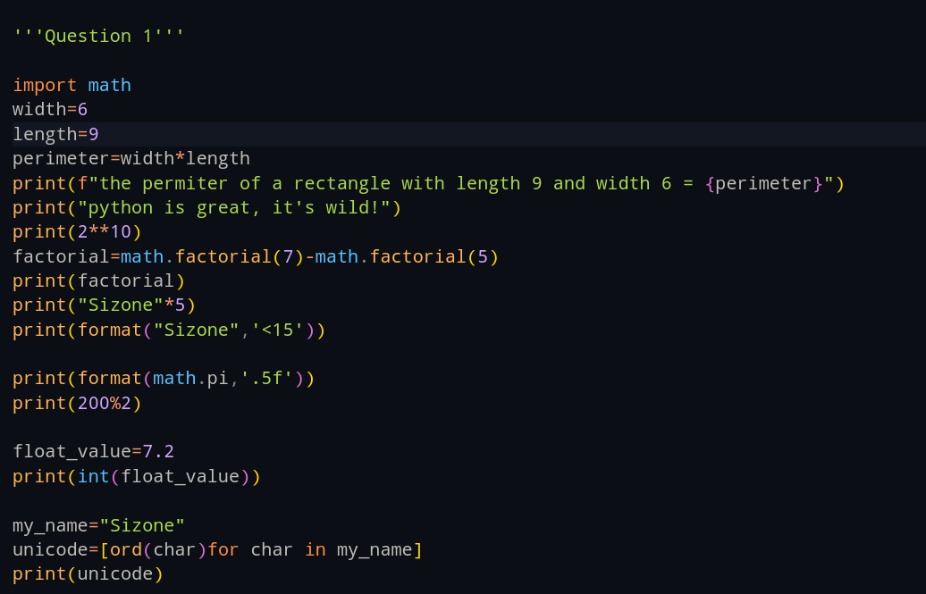

Output Screenshot:
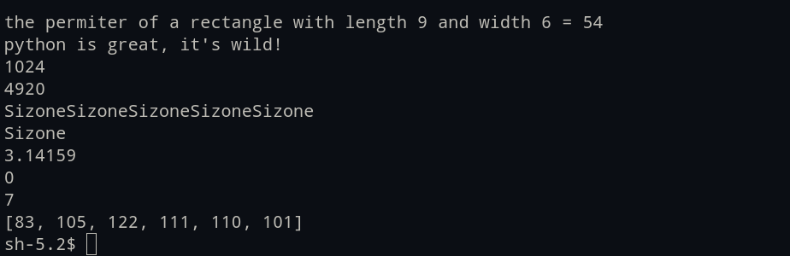

Program 2:

Description of the Program:

A program to take a number input from the user and display whether that number is even or odd.

Source code:
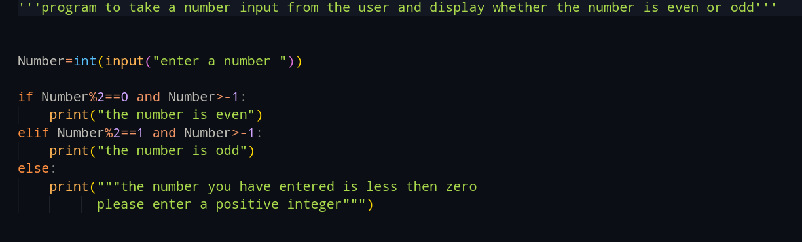

Output screenshot(s):
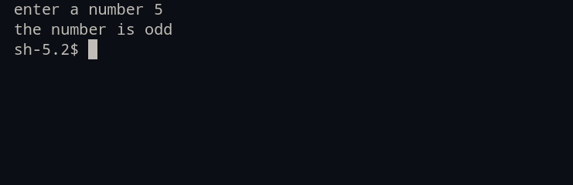

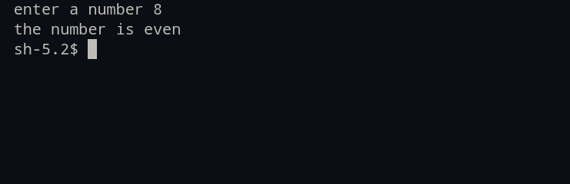

Program 3:

Description of the Program:
a program that prompts the user for two integer values and displays the results of the first number divided by the second, with exactly two decimal places displayed.

Source Code:
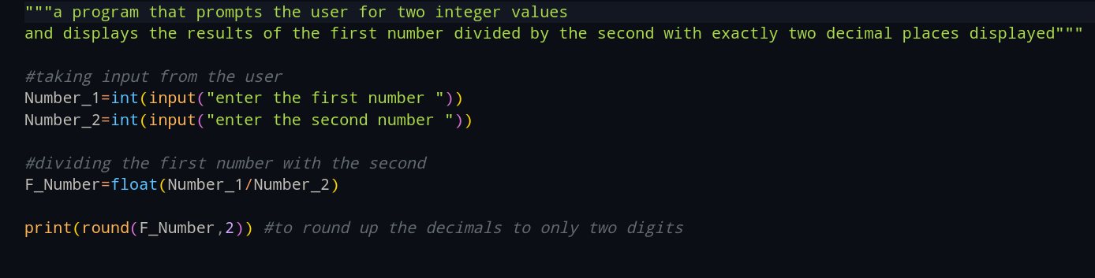

Output Screenshot(s):
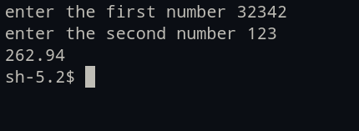

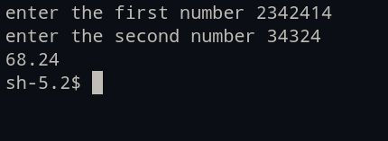

Program 4:

Description of the Program:
A program to convert Celsius value to Fahrenheit.

Source code:
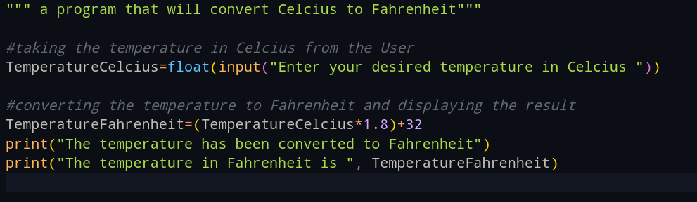

Output screenshot(s):
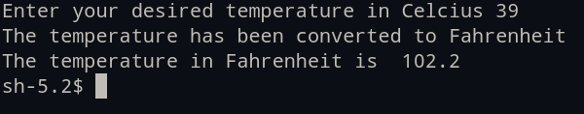

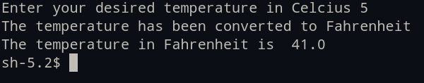

Program 5:

Description of the Program:

A program to find the Euclidean distance between two coordinates. Take both the coordinates from the user as input.

Source Code:

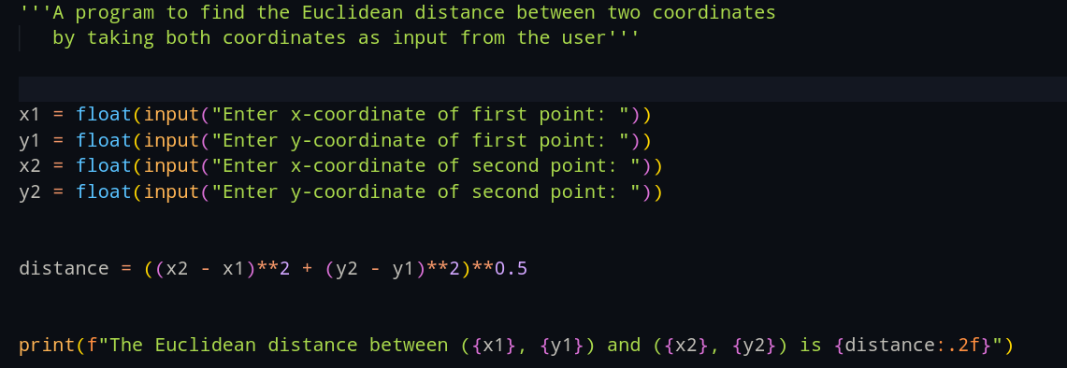

Output Screenshot(s):
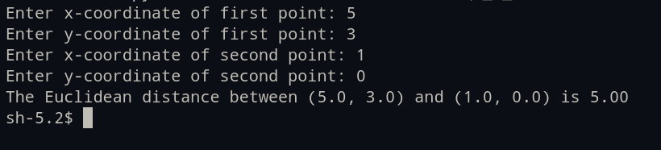

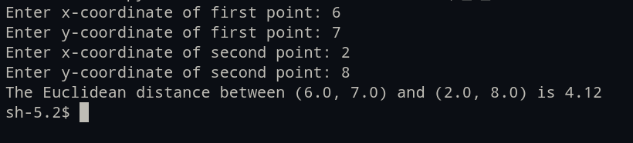

Program 6:

Description of the Program:

A program to find the simple interest when the value of principle, rate of interest and time period is provided by the user.

Source Code:
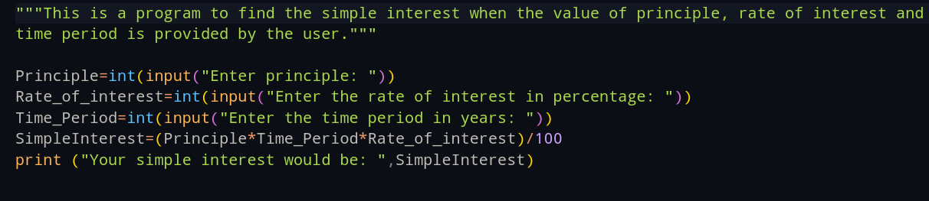

Output Screenshot(s):

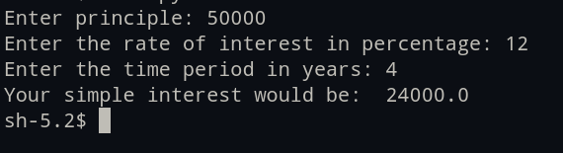

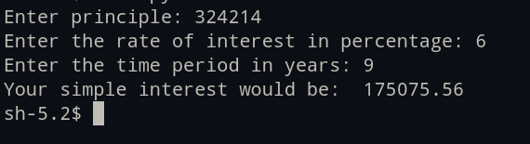

Program 7:

Description of the Program:
A Python program to find those numbers which are divisible by 7 and multiple of 5, between 1500 and 2000 (both included)

Source Code:
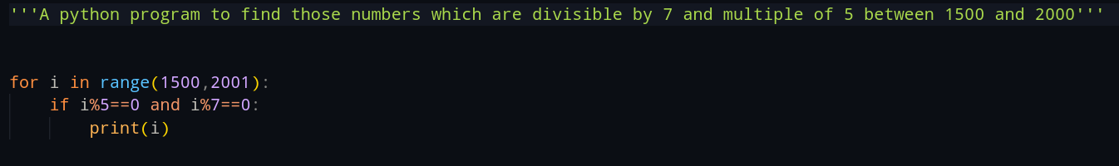

Output Screenshot:


Program 8:

Description of the Program:
A Python program that accepts a string and calculates the number of digits and letters.

Source Code:
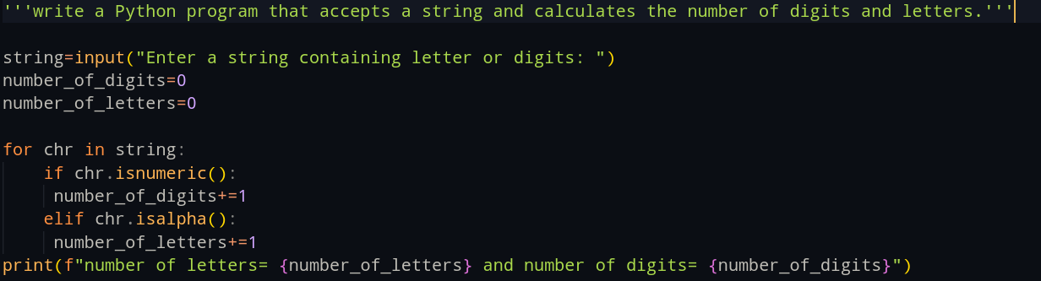

Output screenshot(s):

Program 9:

Description of the Program:
A program to create a number guessing game for the user.

Source Code:
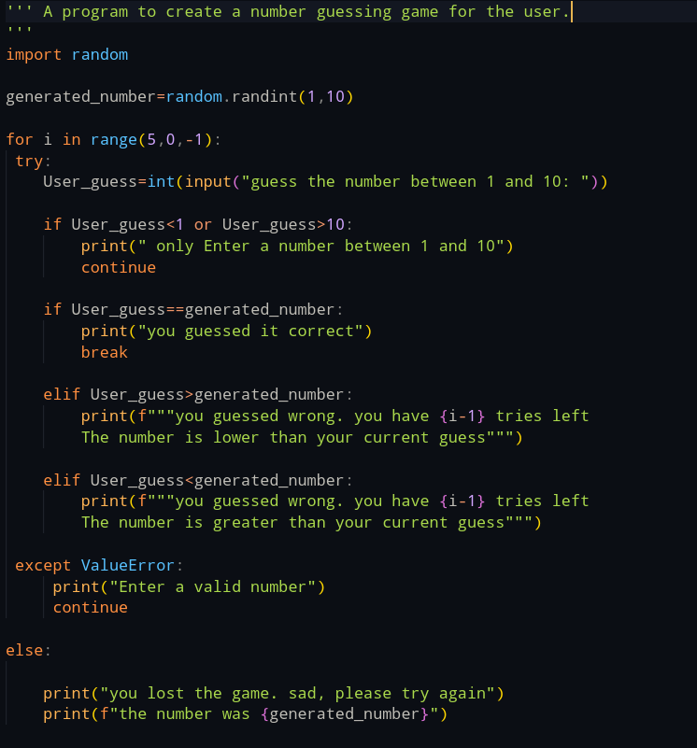
Output Screenshot(s):
